**万法归宗之语法速成进阶**

**第 5 节 非谓语动词（入门）**

**All of model sentences are from a series of movies of MARVEL**

**在英语当中，不充当句子谓语的动词，叫作非谓语动词。由于非谓语动词不受主语的限制，没有时态和语态，所以又叫非限定动词，而谓语动词的形式受到主语的限制，具有时态和语态。非谓语动词有三种形式：动词不定式、动名词和分词。**

**掌握非谓语动词的绝对法则**

1. 判断形式： 不能单独表示时态的动词形式其实就是非谓语。

2. 明确主语： 非谓语动词依然保持动词的含义，所以在逻辑上是有动作的发出者的--逻辑主语

3. 成分功能：一定要根据句式流程图和含义进行完整定位。

**特别总结 ：非谓语动词通常是以短语的形式出现，并在句中做成分。**

**非谓语动词+宾语（从句）**

1. **动词不定式=to+动词原型**

**不定式的概念其实指的是可以做除了谓语以外所有的句子成分。**

**如果to表介词，那么介词后一定接动名词**

**例句：i am looking forward to meeting you**

动词不定式是一种非谓语动词，所谓非谓语动词就是不能作谓语的动词。正因为如此，这不受主语的人称和数的限制，没有人称和数的变化，但它具有动词的某些特征，可以带宾语和状语构成不定式短语。

其构成是：“to + 动词原形”，否定式是：“not to + 动词原形”。

**1. 动词不定式的语法功能（句子成分）**

**（1）作主语：**

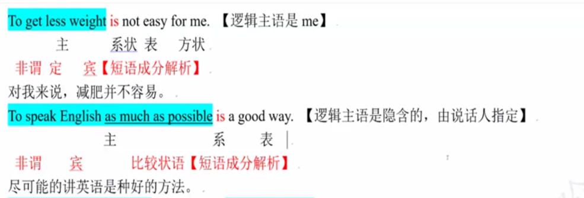



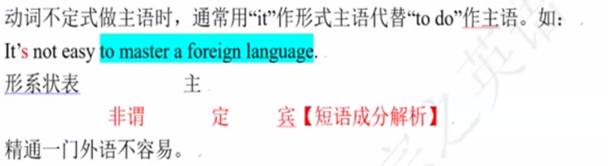



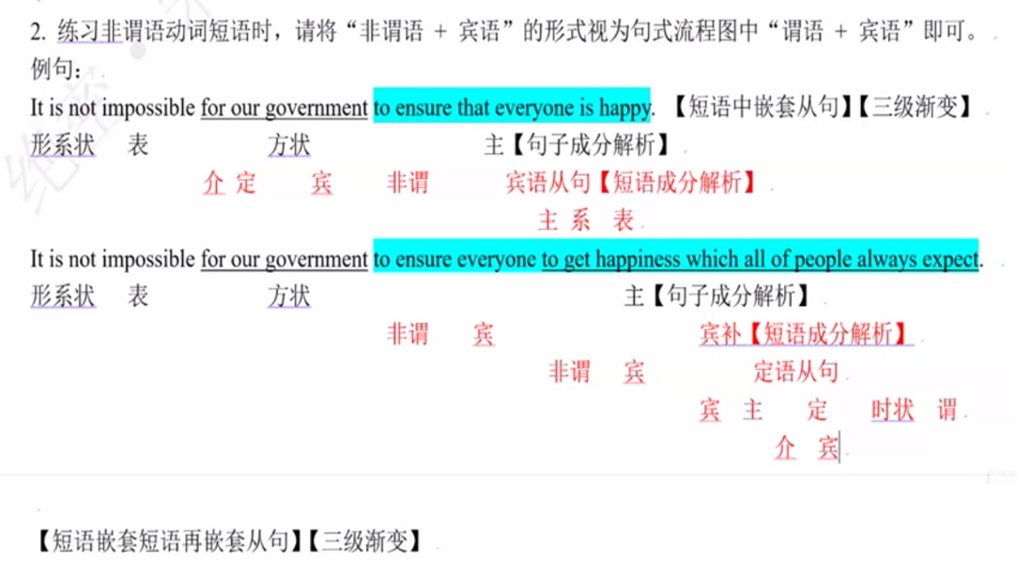

【特别提示】

①不定式作主语时常常用 it 作形式主语，不定式放在谓语之后。

It is not easy for me to get less weight.

It is quiet dangerous to drive fast.

②这种用法可以归纳成这样一个句型

It is (not) + 形容词 + (for sb.) to do sth. 如：

It is very difficult for me to learn English well.

It is fun to talk with that foreigner in that school.

③有些形容词之后跟 of + 名词（代词宾格）+不定式。如：

It is very kind of you to say so.

你这样说真是太好了。

It is very good of you to come.

你来了真是太好了。

**（2）作表语：**

My job is to drive the car for the old man.

The important thing is to study English well.

The purpose of new technologies is to make life easier, but not to make it more difficult.

新技术出现的目的是让生活过得更容易，而不是让它更艰难。

His wish is to be a doctor.

他希望当一名医生。（不定式说明主语的内容）

I was about to leave when he walked into my room.

我正要离开房间时，他走了进来。（不定式表示将来）

【was 表一般过去时+to leave表示将来时=过去将来时】

传统讲法：be about to do 将来时

【be going进行时+to do 将来时=正在去某事的路上=将来时】

**（3）作宾语：**

He wanted to tell you some good advice.

The lights are still on. He must forget to turn off the light.

常见的可以用不定式作宾语的动词有：like，love，begin，start，try，ask，prefer，hate，find 等。有些形容词可接不定式，这种不定式也可作宾语。如：

I’m very glad to see you.

主系 表 宾【句子成分解析】

非谓 宾【短语成分解析】

I’m sorry to hear that.

①不定式作宾语常接在一些及物动词后。如：

—The light in the office is still on.

—办公室的等还亮着。

—Oh, I forgot to turn it off.

—噢，我忘了关了。

Mr. Brown wants to understand further what the author meant.

布朗先生想进一步了解作者的意思。

以下内容实际上就是从句转变为短语的结果

②动词不定式作 tell，show，understand，explain，teach，learn，advice，discuss，know 等动词的宾语

时，前面常带有疑问词。如：

He showed us how to do the work.

He doesn’t know whether to stay or not.

**（4）作定语：不定式做后置定语，必然紧跟名词或代词，而且与前面的名词或代词不构成“逻辑主语”--推论：动词不定式的前面的名词或代词如果可以在含义上做不定式的宾语，那么 这么这个动词不定式一定是定语。**

不定式作定语必须后置，即放在所修饰的名词或代词的后面，通常要注意以下几种情况：

①被修饰的名词或代词是不定式的逻辑主语。如：

Most of the students have a lot of homework to do every day.

每天很多学生要做功课。

The old man wants something to eat.

【something,anything,everything,nothing被形容词修饰时，形容词一律后置，即使是一个形容词来做定语。】

那位老人想吃点东西。

Have you got anything to say for yourself?

Mr. White is a worker, but he has got a large family to support.

②被修饰的名词或代词是不定式的逻辑主语。如：

Captain Cook was the last one to leave the sinking ship.【leave表示离开应视为不及物动词】

库克船长是最后一个离开正在下沉的船的人。

③不定式**说明**它所修饰的名词或代词的内容。--其实是动词不定式在做**同位语**

There is no need to give children so much money.

没有必要给孩子这么多钱。

Her wish to become an artist came true at last.

她最终实现了想成为一名艺术家的愿望。

④不及物动词构成的不定式作定语要加介词。如：

They got a wonderful piece of music to dance to.

他们得到了一支很好的音乐用来伴舞。

Because of air pollution being greatly reduced, this city is still a good place to live in.

因为这个城市的空气污染得到了很大的改善，因此，它仍然是一个好的居住地。

⑤有些及物动词的不定式作定语仍需带上介词。如：

He has got a pair of thick glasses to read with.

他阅读时戴的是一副深度的眼镜。

**（5）作状语：只能依据逻辑主语和语境含义来判断不定式的意义**

He went to the teachers’ office to give the money.

他到老师的办公室去交钱。（表目的）

The boy is too young to do the work.

这个男孩太小，不能做这项工作。（表结果）

I’m so glad to hear that you have passed the exam.【含义：因果】

很高兴听说你通过了考试。（表原因）

i’m so sure to pay for this application.【含义：主谓】

①不定式作目的状语，位于句首时，用逗号隔开；位于句尾时，不同逗号隔开。如：

His stepmother did all she could to help him.

他的继母尽其所能帮助他。

To make a living, he had to work hard.

为了谋生，他只有拼命地工作。

②不定式作结果状语一般表示出乎意料的结果。如：

He hurried to the station only to find the train had left.

他匆忙赶到车站，却发现了火车已经开走了。

I woke up to find everybody gone this morning.

今天早上，我醒来时发现大家都走了。

③不定式作原因状语，其主要用于形容词作表语时，表示喜、怒、爱、乐等。如：

I’m too glad to see you again.

我真高兴能再次见到你。

（It is）nice to meet you

He is ready to help others all the time.【to help 还是习惯性的视为宾语】

他总是乐意帮助别人。

**（6）作宾语补足语或主语补足语：（主语补足语出现在概率极少）**

不定式是用来补充说明宾语的，通常不定式的动作是宾语发出的。经典可以带不定式作宾语的动词有：

ask sb. to do sth.，want sb. to do sth.，tell sb. to do sth.，like sb. to do sth.，help sb. (to) do sth.，还有些动词可

以省略 to 的不定式作宾语补足语。如：hear，watch，see，feel，make，let，have 等。如：

I often help my mother to do housework.

He saw the thief go into the room quickly.

The teacher asked us to stop reading.

He asked me to buy some food for him.

My friend often helps me learn English.

【特别提示】

**还有些使役动词和感官动词也用不定式作宾语，这时候不定式要省掉 to。这些动词有：**

**一感（feel）；**

**二听（hear，listen to）；**

**三让（let，make，have）**

**四看（look at，see，watch，notice）。**

**但是在变成被动语态时，必须加上 to。**

常带 to do 作宾补的动词有：allow，permit，cause，encourage，expect，force，invite，order，warm，tell，

consider（认为），require，advice，teach，urge 等。如：

They would not allow him to risk going across the enemy line.

他们不允许他冒险越过敌人的封锁线。

The patient was warned not to eat oily food after the operation.

病人被告知手术后不要吃油腻的食物。

比较：Mr. Black invited me to have a dinner with him.

布莱克先生邀请我和他一起吃晚餐。（to have 的逻辑主语是 me）

Mr. Black promised me to have a dinner with me.

布莱克先生答应和我一起吃晚餐。

**~~（7）不定式作同位语~~【直接并入不定式做定语中即可】**

~~His wish to be a sailor never comes true.~~

~~I’ve no idea where to hold the party.~~

**（8）不定式作独立成分（插入语）。如：**

To be fair, he was worked hard these days.

说句公道话，他这几天工作很努力。

类似的常见短语还有 to be frank，to be true，to tell (you)，the truth，to begin with，to be honest 等。

1. **不定式的独立主格结构。**

**【独立主格会进行专题解析，但只要记住独立主格来源于非谓语】**

由“名词或代词+不定式”构成独立结构。如：

More time to be given, they will make much more progress.

如果能给更多的时间，他们会取得更大的进步。

No one to come tomorrow, we’ll have to put off the meeting till next month.

如果明天没有人来，我们将不得不把会议推迟到下个月。

The exam to be held next week, I can’t go with you.

因为下周要考试，所以我不能跟你一起去了。

**（10）不定式有时可以表示条件【视为条件状语，一定要准确理解含义】。如：**

To look at him, you’d like him. = If you are to look at him, you’d like him.

巧学妙记：

①不定式作定语时，置于被修饰的名词之后。

②作定语的不定式与所修饰的名词有逻辑上的动宾关系时，动词若是不及物动词，必须带有介词，使

其成为及物的短语动词。

③不定式作结果状语，通常用于这五种句型：so … as to do；such … as to do；… enough to do；too …

to do；only to do。

④在一些形容词、动词后的不定式，如果重复前面的动词，to 后的动词可以省略，只保留不定式符号to。

**二、动名词：直接视为名词即可**

动词的 ing 形式具有名词的特性。它在句子里主要做主语、宾语、表语和定语。

1. 动名词的语法功能

（1）作主语。如：

一般情况下表示一种抽象、泛指的动作，而不是一次性的具体的动作。动作的 ing 形式作主语时，常采用形式主语 it。

Swimming in this river is dangerous.

Reading aloud is very important in learning a foreign language.

Fishing is his favourite hobby, and collecting coins also gives his great pleasures.

（2）作表语。如：

My job is teaching English.

His hobby is collecting stamps.

（3）作宾语。如：

英语中有些动词只能接名词作宾语，不能接不定式，这些动词有：admit（承认）；avoid（避开）；can’t help（禁不住）；consider（考虑）；deny（否认）；enjoy（喜欢）；excuse（原谅）；finish（完成）；mind（介意）；practice（练习）；miss（错过）；suggest（建议）；如：

The girl can’t help crying at last.

We enjoyed playing football after school.

I can’t understand his giving up such a well-paid job.

We should practice speaking English every day.

（4）作定语。如：

Who won the swimming competition?

This is a writing table and that is a swimming pool.

~~He asked an embarrassing question.~~ 【embarrassing 本身就可表形容词】

**三、分词**

1. 分词的语法功能

（1）作表语

分词可以用来作表语。这样用时，现在分词多表示主语所具有的特征①，过去分词多表示主语所处的

状态②。如：

①The situation is encouraging.

形式很令人鼓舞。

The theory sounds quite convincing.

这理论听起来很有说服力。

The food smells inviting.

食物香味诱人。

②The door remained locked.

门仍然锁着。

He felt rather let down by their indifference.

他们的冷漠使他感到相当失望。

The bottle is broken.

瓶子破了。

1. 作定语

①作定语的分词可以是现在分词的一般式和被动式，也可以是过去分词。如：

He is a promising young man.

他是一个很有前途的青年。

The meeting being held is very important.

正在举行的会议很重要。

The Olympic Games held in Beijing is a great success.

在北京举行的奥运会非常成功。

②现在分词和动名词作定语的区别：一般说来，现在分词作定语表示所修饰的人或物的动作，而动名词则

表示所修饰物的作用。如

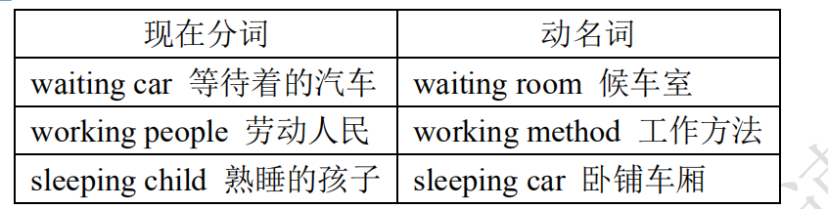

③过去分词和现在分词的被动式作定语的区别：

过去分词的被动式作定语时表示动作在谓语动词所表示的动作之前发生，或没有一定的时间性。如：

Have you read the novel written by Dickens?

你读过狄更斯写的小说吗？

He is man loved and respected by all.

他是一个被所有人爱戴和尊敬的人。

Don’t use words, expressions, or phrases known only to people with specific knowledge.

不要使用只有专业知识的人才懂得单词、表达法或短语。

现在分词的被动式作定语时表示动作正在发生或与谓语动词所表示的动作同时发生。如：

Listen! The song being sung is very popular with the students.

听！正在唱的这首歌非常受学生的欢迎。

The building being built is our lab.

那座正在修建的建筑是我们的实验楼。

④单个分词作定语置于被修饰词的前面；分词短语作定语，置于被修饰词的后面。如：

Power stations employ falling water to produce electricity.

发电站用流水发电。

China is a developing country and belongs to the third world.

中国是发展中国家，属于第三世界。

The teacher answered all the questions raised by the students.

老师回答了学生提出的所有问题。

We know an object weighing 6 kilograms on the earth weighs 1 kilogram on the moon.

我们知道在地球上重 6 千克的物体在月球上重 1 千克。

（3）作状语

①分词做状语时，分词的逻辑主语必须与句子的主语保持一致。分词作状语必须和句子的主语含有逻辑

上的主谓或动宾关系，否则不能使用分词做状语。如：

He sent me an E-mail, hoping to get further information.

他给我发了封邮件，希望能得到进一步的信息。

Founded in 1636, Harvard is one of the most famous universities in the United States.

成立于 1636 年的哈佛是美国最著名的大学之一。

②如果作状语的分词带有逻辑主语，即构成独立主格结构。独立主格结构通常由“名词（词组）或代词主

格+分词”构成，这种结构可以作时间、原因、条件、方式和伴随状语。如：

Mr. Cook being away from home, his wife has to do all the housework. （原因状语）

由于库克先生不在家，他妻子必须做所有的家务。

Work done, they went out to play football. （时间状语）

工作完成后，他们出去踢足球。

More time given, the work can be done much better. （条件状语）

如果再多给点时间，工作会做得更好。

The tourist visited many scenic spots in Beijing, the guide acting as interpreter. （伴随状语）

游客们参观了许多风景名胜，导游当翻译。

The students rushed out of the classroom, each carrying a number of new books under arm. （伴随状语）

学生们冲向教室外，每人手臂下抱着许多新书。

There being no buses, we had to walk to go back home. （原因状语）

由于没有公交车，我们只能步行回家。

③分词或分词短语作状语时，可以表示时间、原因、结果、条件、让步、方式、伴随等。表示时间关系

的分词短语有时可由连词 while 或 when 引出。如：

Be careful when / while crossing the street. （时间）

穿过街道时要小心。

Not knowing anything about the accident, he went to work as usual. （原因）

还不知道发生了车祸，他和往常一样去上班。

Given a chance, I can surprise the world. （条件）

只要有机会，我能使全世界吃惊。

Having been told many times, he still repeated the same mistake. （让步）

尽管已经告诉他很多次，他仍犯同样的错误。

The teacher came into the lab, followed by some students. （伴随）

老师走进实验室，后面跟着几名学生。

The cup dropped to the ground, breaking into pieces. （结果）

杯子掉到地上，打碎了。

Excited and happy, he came running in. （伴随）

他跑进来，既激动又高兴。

④独立成分作状语。有些分词短语，其形式的选择不受上下文的影响，称作独立成分。如：

generally/frankly/honestly/strictly speaking，judging from / by，considering，supposing，taking sth. Into

consideration 等。如：

Generally speaking, boys are more interested in such games than girls.

总体上说，男孩比女孩对这种游戏更感兴趣。

Considering everything, John isn’t so bad after all.

所有事情都考虑起来，毕竟约翰不是那么差劲。

Supposing there was a war, what would you do?

假设发生了战争，你会做什么？

（4）作宾语补足语

①感官动词 see，watch，observe，look at，hear，listen to，notice 等和使役动词 have 后面的宾补有三种形式，

即动词原形、现在分词和过去分词。动词原形表示主动和完成，现在分词表示主动或正在进行，过去分词

表示被动或完成。如：

I heard her sing an English song just now.

刚才我听见她唱了一首英文歌。

I heard her singing an English song when I passed by her room yesterday

昨天经过她房间时，我听见她在唱英文歌。

I heard the English song sung many times.

我多次听到有人唱过这首英文歌。

注意：不及物动词的过去分词作宾补表示完成或状态。如：

I looked down at my neck and found my necklace gone.

我低头看了一眼我的脖子，发现我的项链不见了。（状态）

I was surprised to find my hometown changed so much.

我惊奇地发现我的家乡变化很大。（完成）

②leave 后接三种形式作宾补时，其中的 leave 保留了原意“留下”，但表达的确切之意应是“使……处于某种

状态”。

leave sb. doing sth. 让某人一直做某事

leave sth. undone 留下某事未做

leave sb. to do sth. 留下某人做某事

leave sth. to be done 留下某事要做

如：It’s wrong of you to leave the machine running.

The guests left most of the dishes untouched.

He went to watch the game, leaving me to do all the rest work.

We hurriedly ended our meeting, leaving many problems to be settled.

③have，get 后接三种形式作宾补时，其中 have，get 表示“使，让，叫”。

1) get / have sth. done 使/让某事由别人去做。如：

I’ll get / have my bike repaired tomorrow.

此外，have sth. done 还表示“使遭受”。如：

Tom had his house broken into while he was away on holiday.

2) have sb. / sth. doing 使/让某人/物持续地做事。

get sb. / sth. doing 使某人/物开始行动起来。如：

The peasants had the tractor working day and night at the harvest time.

The captain got the soldiers moving toward the front after a short rest.

注意：have sb. doing 用于否定句中时，其中 have 有“容忍”之意。如：

I won’t have you speaking to your parents like that.

Don’t have the water running all the time.

巧学妙计：分词有动词的意义和性质，可以带有自己的宾语或状语，在句中可以作定语、表语、补语

和状语；现在分词表示主动、正在进行或发生；过去分词表示被动或完成。

**强化训练与课后作业**

**《Avengers I》**

**要求：标出下列句子中的非谓语动词部分，并确定其所充当的句子成分。**

1. 00:49

He is ready to lead and our force, our Chitauri, will follow.

2. 01:05

And the humans, what can they do but burn?

3. 02:13

NASA didn't authorise Selvig to go to test phase.

4. 02:31

We should tell them to go back to sleep?

5. 02:37

I need you to make sure the Phase 2 prototypes are shipped out.

6. 03:06

Is that supposed to be funny?

7. 06:42

This doesn't have to get any messier.

8. 07:05

Are you planning to step on us?

9. 11:20

I want every living soul not working rescue looking for that briefcase.

10. 12:12

This is not how I wanted this evening to go.

11. 12:16

I know how you wanted this evening to go.

12. 12:51

The famous Black Widow and she turns out to be simply another pretty face.

13. 13:06

Tell Lermentov we don't need him to move the tanks.

14. 13:54

We need you to come in.

15. 14:15

Let me put you on hold.

16. 15:05

But first, we need you to talk to the big guy.

17. 17:49

I don't think you want to break that streak.

18. 18:41

Stop lying to me!

19. 18:50

I just wanted to see what you'd do.

20. 21:38

Then you should be out, celebrating, seeing the world.

21. 22:36

There's a lot we'll have to bring you up to speed on if you're in.

22. 22:51

There's a debriefing packet waiting for you back at your apartment.

23. 22:57

Is there anything you can tell us about the Tesseract that we ought to know now?

24. 26:08

I don't like being handed things.

25. 28:32

I gotta say, it's an honour to meet you officially.

26. 28:48

You know, it's really just a huge honour to have you on board this.

27. 32:13

It was quite the buzz around here, finding you in the ice.

28. 34:36

Let's vanish.

29. 35:11

Doctor, thank you for coming.

30. 35:14

Thanks for asking nicely.

31. 35:39

Call every lab you know. Tell them to put the spectrometers on the roof and calibrate them for gamma rays.

1. 36:56

It took me a couple of years to collect them all.

33. 41:20

You know, the last time I was in Germany, and saw a man standing above everybody else.

34. 43:04

What, Rock of Ages giving up so easily?

35. 43:06

I don't remember it being that easy.

36. 43:18

You might have missed a couple of things doing time as a Capsicle.

37. 44:59

Do I look to be in a gaming mood?

38. 45:46

I remember you tossing me into an abyss.

39. 46:57

You need the Cube to bring me home.

40. 49:34

Now, I don't know what you plan on doing here.

41. 49:45

You want me to put the hammer down?

42. 52:19

It burns you to have come so close.

43. 53:04

He has an army called the Chitauri.

44. 53:11

He means to lead them against your people.

45. 55:26

Dr Banner is only here to track the Cube.

46. 55:38

And I would like to know how Loki used it to turn two of the sharpest men I know into his personal flying

monkeys.

47. 56:13

But it's going to take weeks to process.

48. 58:11

I should probably look into that once my decryption programme finishes breaking into all of S.H.I.E.L.D.'s secure

files.

49. 59:44

You know, I've got a cluster of shrapnel trying every second to crawl its way into my heart.

50. 01:05:44

Your ledger is dripping. It's gushing red and you think saving a man no more virtuous than yourself will change

anything?

51. 01:10:09

I'm starting to want you to make me.

52. 01:10:28

You're not the guy to make the sacrifice play, to lay down on a wire and let the other guy crawl over you.

53. 01:10:40

You may not be a threat but you better stop pretending to be a hero.

54. 01:11:48

I focused on helping other people. I was good.

55. 01:12:27

I'm not afraid to hit an old man.

56. 01:13:09

but it's impossible to get out there to make repairs while we're in the air.

57. 01:24:09

We started working on the prototype after you sent the Destroyer.

58. 01:29:49

Maybe I had that coming.

59. 01:30:23

The idea was to bring together a group of remarkable people to see if they could become something more.

60. 01:30:43

Phil Coulson died still believing in that idea.

61. 01:35:41

Why? For believing? For taking on Loki alone.

62. 01:41:13

when they are so busy fighting you?

63. 01:49:17

There are people inside and they're going to be running right into the line of fire.

64. 01:51:34

Now might be a really good time for you to get angry.

65. 02:15:41

To challenge them is to court death.